**Feature importance and interpretability**how do you get **Feature importance** in NB?  
Those who have likelihood values, are most important features  
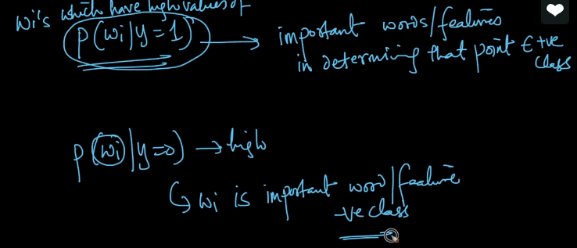  
 In other words, we need to find out P(wi/y=1) and P(wi/y=0) for words. Highest of these values will become important features to define class label of any text.  
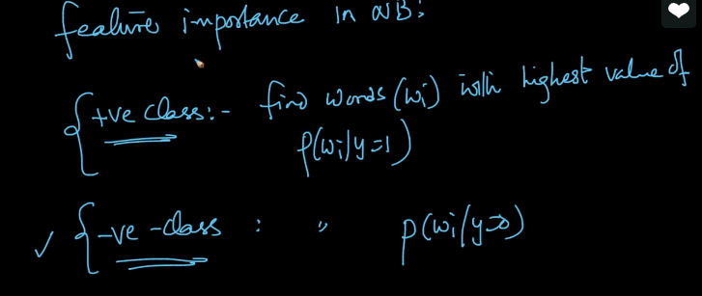  
we can get this value directly from model which is not possible in KNN.  
In KNN we used – forward selection feature

**Interpretability:**let’s say we have set of words {w1,w2,w3,w4,w5,w6,w7,w8,w9..w20} in Xq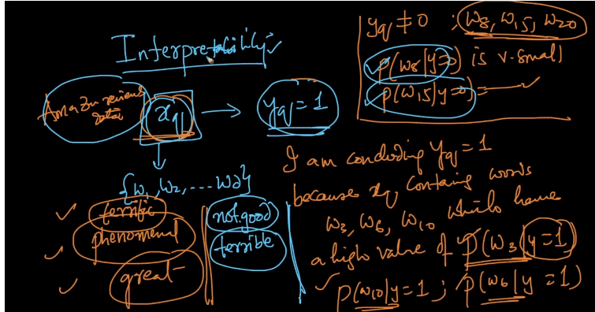So, we given Yq with some words exits in Xq. Just by assumption, **I can conclude Yq class label as 1 because Xq contain words w3,26,w10 which have high likelihood values and Yq is not equal to 0 w8,w5,w20 have low likelihood values.**